Lesson Plan
Teacher: V. Patskan Form 5
Topic: Nature and Weather
Microtopic: Everything is good in its season
Objectives: by the end of the lesson pupils will be able (Slide 2 )
- to describe the weather using new lexical units and impersonal sentences;
- to activate using of the modal verb “can”;
- to work in pairs and groups.
- to communicate with each other.
- to develop listening, reading, speaking skills;
Materials to be used: presentation, flash card, cards, text for reading, song.
Type of the lesson: combined
Procedure
- Introduction
Greeting.Good morning, pupils! I am very glad to see you! How are you?
Aim. The theme of our today’s lesson is “Nature and Weather. Everything is good in its season”. The aim of our lesson is to refresh your vocabulary on this topic and improve your reading, listening and speaking skills.
Phonetic Warm- up.
- But at first let’s start with sounds. When you hear the sound, clap your hands.
Sound [Λ] I like to run
Out in the sun
It’s such a fun
To run, to run. (Slide 3 )
Lexical warm-up
Teacher: So, as you’ve already guessed today we’ll speak about the weather. I know that this topic is familiar for you and you know many words to describe the weather. Let’s repeat them. (With the help of emblems the teacher divides the pupils into two teams.)
Teacher: Children, take your places according to your emblems and divide into two teams. The name of the first team is “Flowers” and the second team is “Snowflakes”. Look at the screen. You see the pictures, describing different weather. Your task is to hang the corresponding words under the picture (Slide 4,5) (Handouts).
Checking home work:
Teacher: Pupils, the topic of your previous lesson was “Seasons”. Let’s repeat lexical units. Look at the screen. Here you can see 4 pictures and 4 descriptions of each season. Match the weather to the seasons (Slide 6).
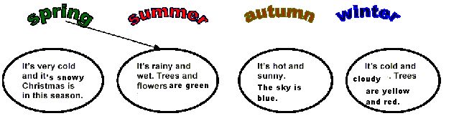IV. Practicing of speaking and writing
- Pair work:
T: Our lesson goes on. Look at the screen .What can you see? You are right! It’s the map of Ukraine. You can see the name of four cities on the map. Each team has to act out the dialogue in pairs. (The example of the questions is written below the map. Pupils make up and act out their dialogues). (Slide 7)
Then, the teacher asks some questions to the pupils:
Example: 1. In what city of Ukraine is it the coldest?
2. In what city is it the warmest?
3. Is the weather in … sunnier than in …?
Listening. Song. (slide 8)
Teacher: Now I want you to sing a song. I’ll give you handouts. There are some missing words in it. Your task is to fill in the gaps. (Handouts).
Teacher: So, pupils, we have already learnt a lot about the weather and now we will speak about sport in different seasons. For the next task you will be divided into two groups
Group work.
Pupils are divided into two groups: the 1st group has to remember names of indoor games and the 2ndgroup has to remember names of outdoor games as many as they can.
e.g. Indoor games: playing chess, karate, boxing, handball;
Outdoor games: Snowboarding, skiing, football, riding by bicycle.
Working in groups pupils have to divide sports to: (slide 9)
Winter sports Summer sports
Snowboarding, football,
skiing cycling
hockey tennis
sledging swimming

And now, pupils look at the slide and match the word with the picture; (slide 10)

FOOTBALL HOCKEY
  CYCLING 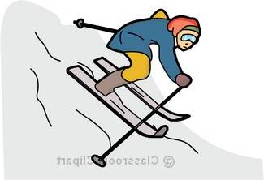 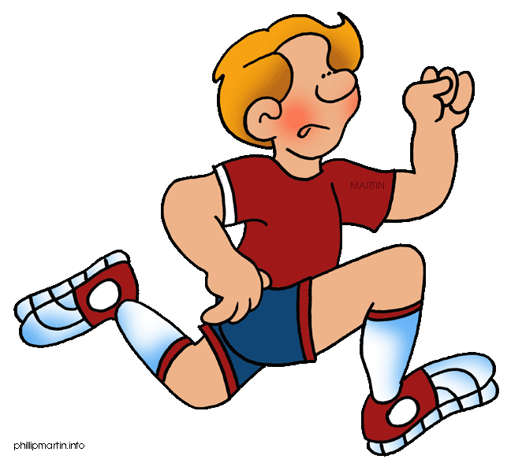
SKIING RUNNING
T: Now make your own sentences about sport that you can do.
e.g. I can swim. I can skate. I can ride a bike.
Break.Would you like to have a rest? OK. Let’s sing a song and do exercises.
(Song “I can run”). (slide 11)
Break. The wind blows, the wind blows
The leaves fall down, the leaves fall down
We gather the leaves, we gather the leaves
And we jump (run, go, fly, swim) and sit down.
Reading. Pre-reading .
So pupils would you like to tell me when we can play snowballs?
When do we go to the skating rink?
When do we celebrate Christmas or New Year?
So how do you think about what season we are going to read now? OK. You are right. It’s winter.
While- reading.
T: Read the text. (HANDOUTS)

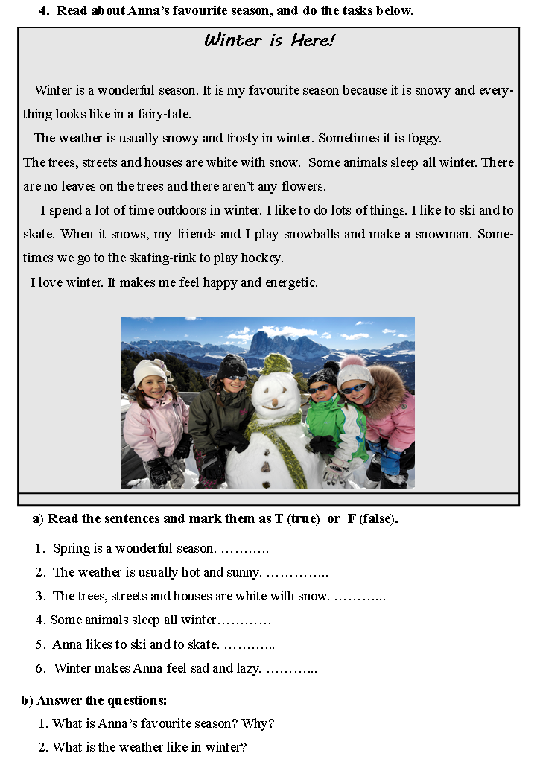 3. What does Anna do in winter?
4. Are there any flowers in winter?
5. What is your favourite season? Why?
Speaking.
So pupils we have read about Anna’s favourite season and now let’s try to discuss another three seasons. Use a plan as a help.
(Pupils are divided into three groups and each of the group describes one season)
the 1st group- spring
the2nd group-summer
the 3rd group – autumn
Use the plan and the prompts to describe seasons. (slide 12)
Plan
- Say what is your favourite season;
- Describe the weather and nature;
- Say what you can do at this season;
- Say how this season makes you feel.
Use the prompts:
- Favourite season – beautiful, fantastic;
- Weather and nature – sunny, rainy, snowy, birds sing;
- Activities – to swim, to ski, to play tennis;
- Feelings – feel happy, energetic, relaxed.
III. Last part of the lesson.
Summing-up activities/ Home assignment
T: What have you learnt at today's lesson? What can you do now?
S₁: I can recognize different kinds of sports.
S₂: I can speak about different sports in different seasons.
T: Your home task for the next lesson will be to write about your favourite season. (slide 13)
- My favourite season is… .
- I think that… .
- I can play... .
- I like … because… .

T: Thank you for your work. Your marks are …
T: The lesson is over. Have a nice day.

