Діагностична робота № 7
Form 3
Name and Surname
Task 1. Unscramble and write.
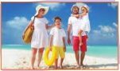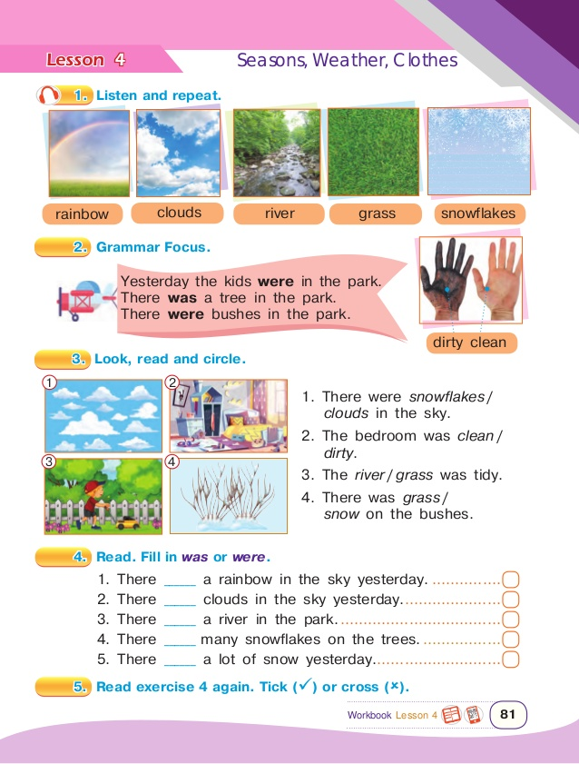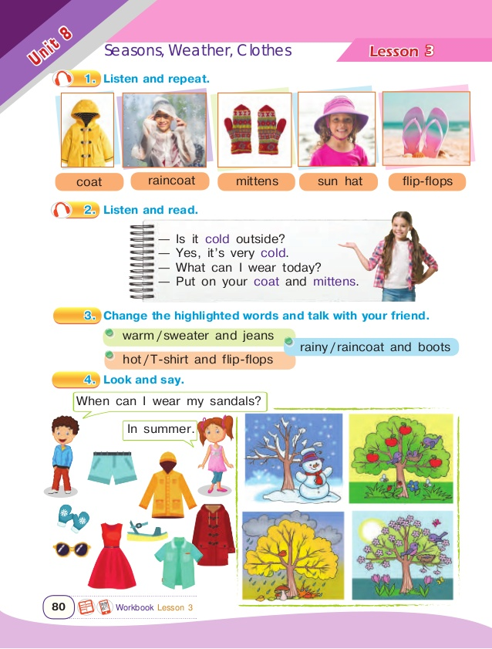
_____________ __________ _____________ _______________
Task 2. Read and number.
1. The bushes are orange and brown. It's cold and windy.

3. It's cold. It often snows.
2. The trees are green. It's warm and sunny.
1. It's hot. People wear sun hats.

4
3
2
1
Task 3. Write in plural. Complete the sentences with was or were.
Task 4. Look at the picture and write the correct words.
